CSCI 5380 - Network Virtualization and Orchestration

Lab 9
Automate VM, VN, Docker, and BGP path

University of Colorado Boulder
Department of Computer Science
Network Engineering

Professor Levi Perigo, Ph.D.

Summary:
In this lab, you will use what you have learned in previous labs and automate the processes into a single application.
Required technologies:
- BGP
- Hypervisor/Orchestrator (such as OpenStack)
- Containers
- SDN Controller
- Hardware server
- Service-chain

Objectives: Virtualized Network Automation
Create an application that meets the following functionality (each objective must be a separate Python module in your code i.e. your main .py file should import the different modules you write):
- Automate the creation of multiple virtual networks (VNs) within the hypervisor and their connection to the public network.
- Automate the creation of multiple VMs within the hypervisor-
  - Both single tenant (same VN) and multi-tenant (different VNs).
  - All VMs should be accessible from the host server and be able to access the Internet.
- Automate the security groups and port security configuration to make intra-VN and inter-VN communication possible.
- Automate spinning up and configuring a Quagga/FRR BGP router as a Docker container.
- Automate its BGP configuration to peer with the SDN controller in the next objective.
- Automate spinning up and configuring an SDN controller as another Docker container.
  - Automate its BGP speaker configuration to peer with Quagga/FRR.

Deliverable:
Create a personal GitHub page that demonstrates the required functionality.

I created an main script which imports all the modules and at the start it asks for option from user to configure the network and names based on which it configures the container and I have used FRR –

I am using clouds.yaml file to allow my scripts to interact with the openstack -

Creation of network in openstack –
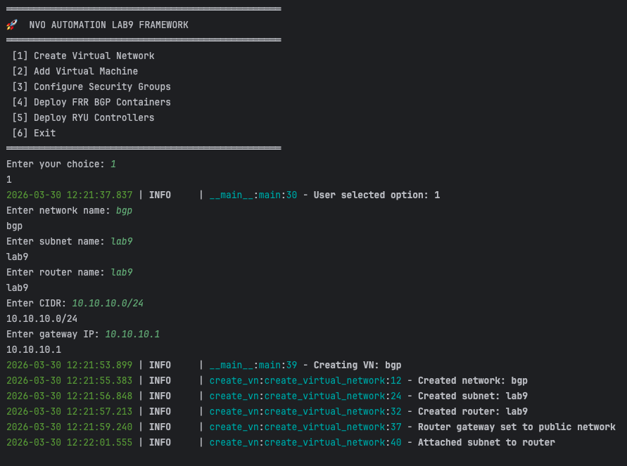

We could verify the openstack UI and see the network and routers are created –

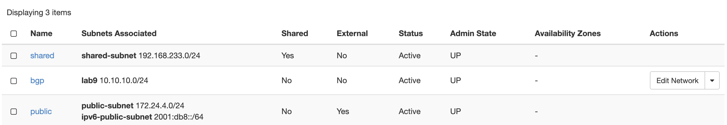
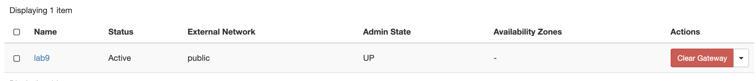

Once the network is created – I used option 2 to create an VM and mentioned same for network –
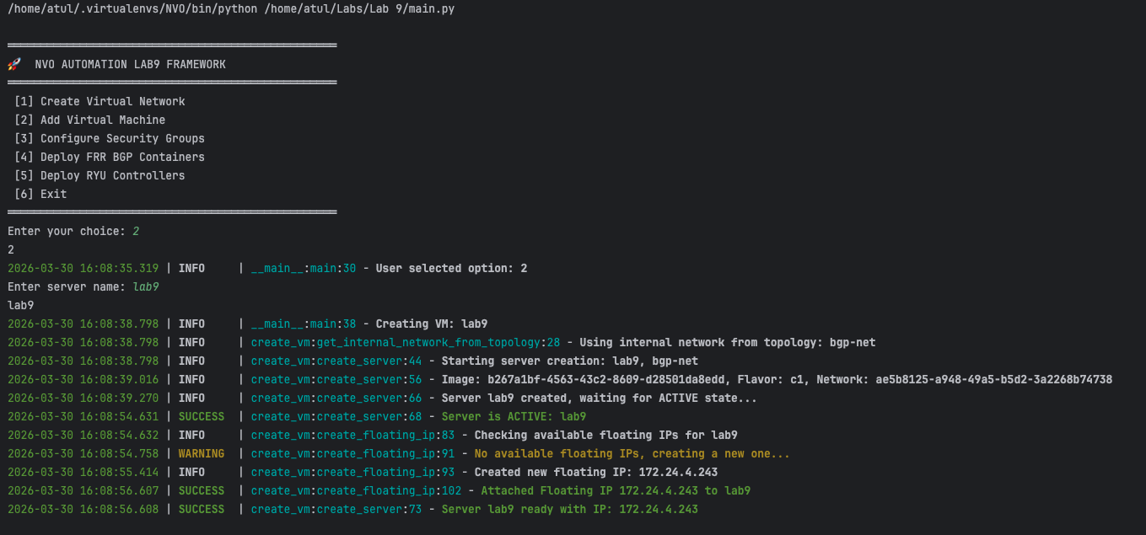

Since the Network creation happened using a topology json file where name of the network and subnet were defined – the script found it from same place.
We could also verify that the floating IP is also added so the instance will be able to ping each other.

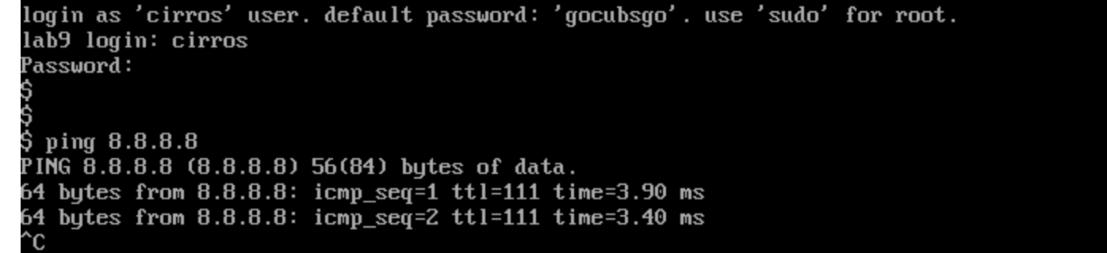

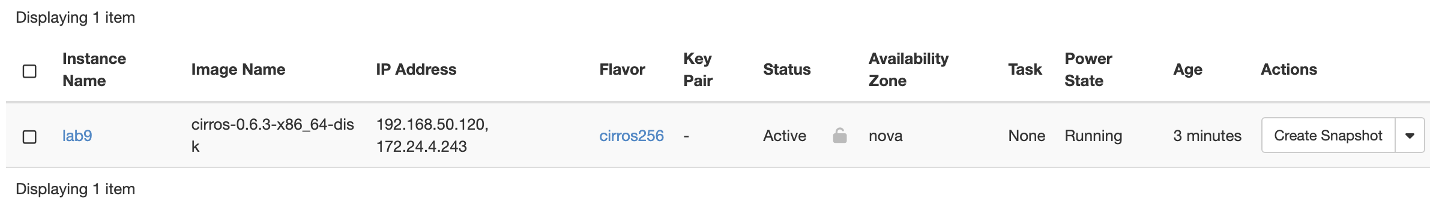
Next steps are to create security group settings -
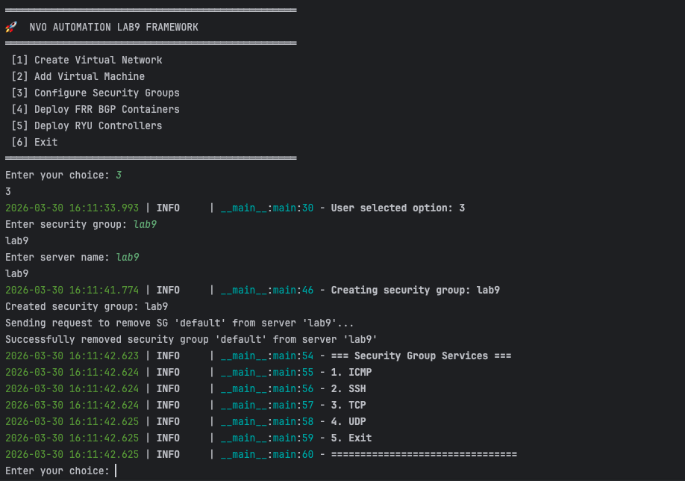

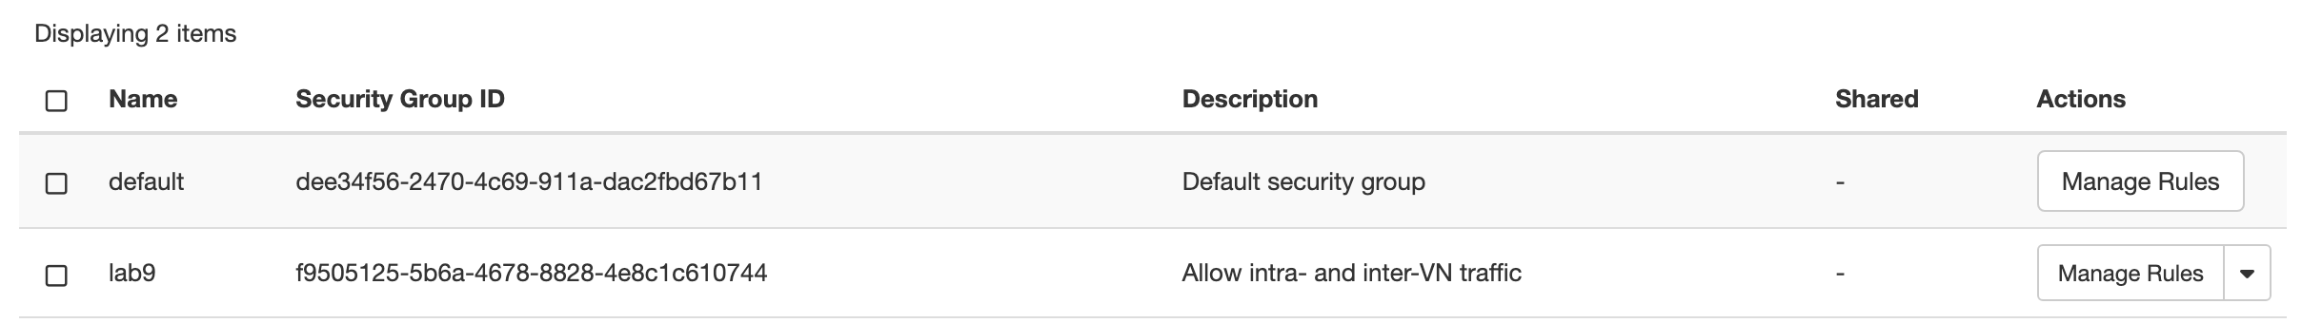

We allowed ICMP –

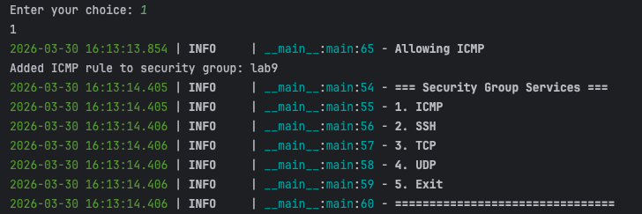

We also allowed SSH rules –
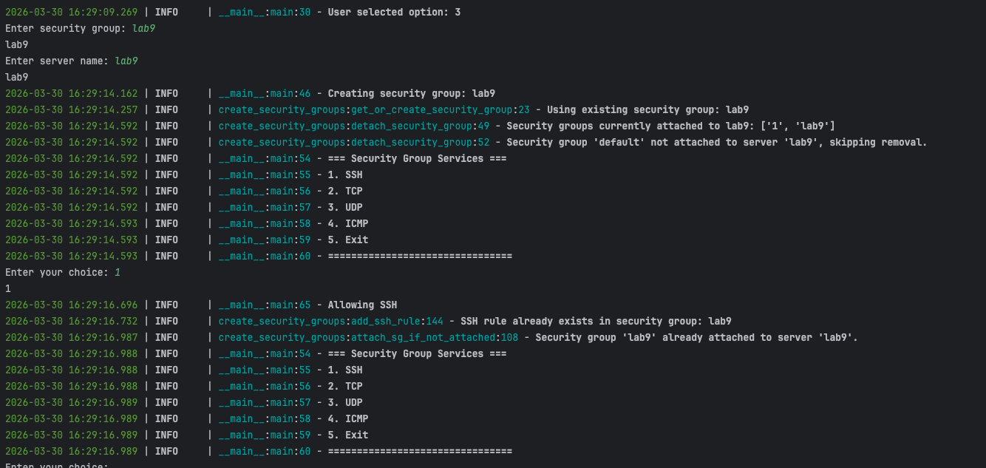

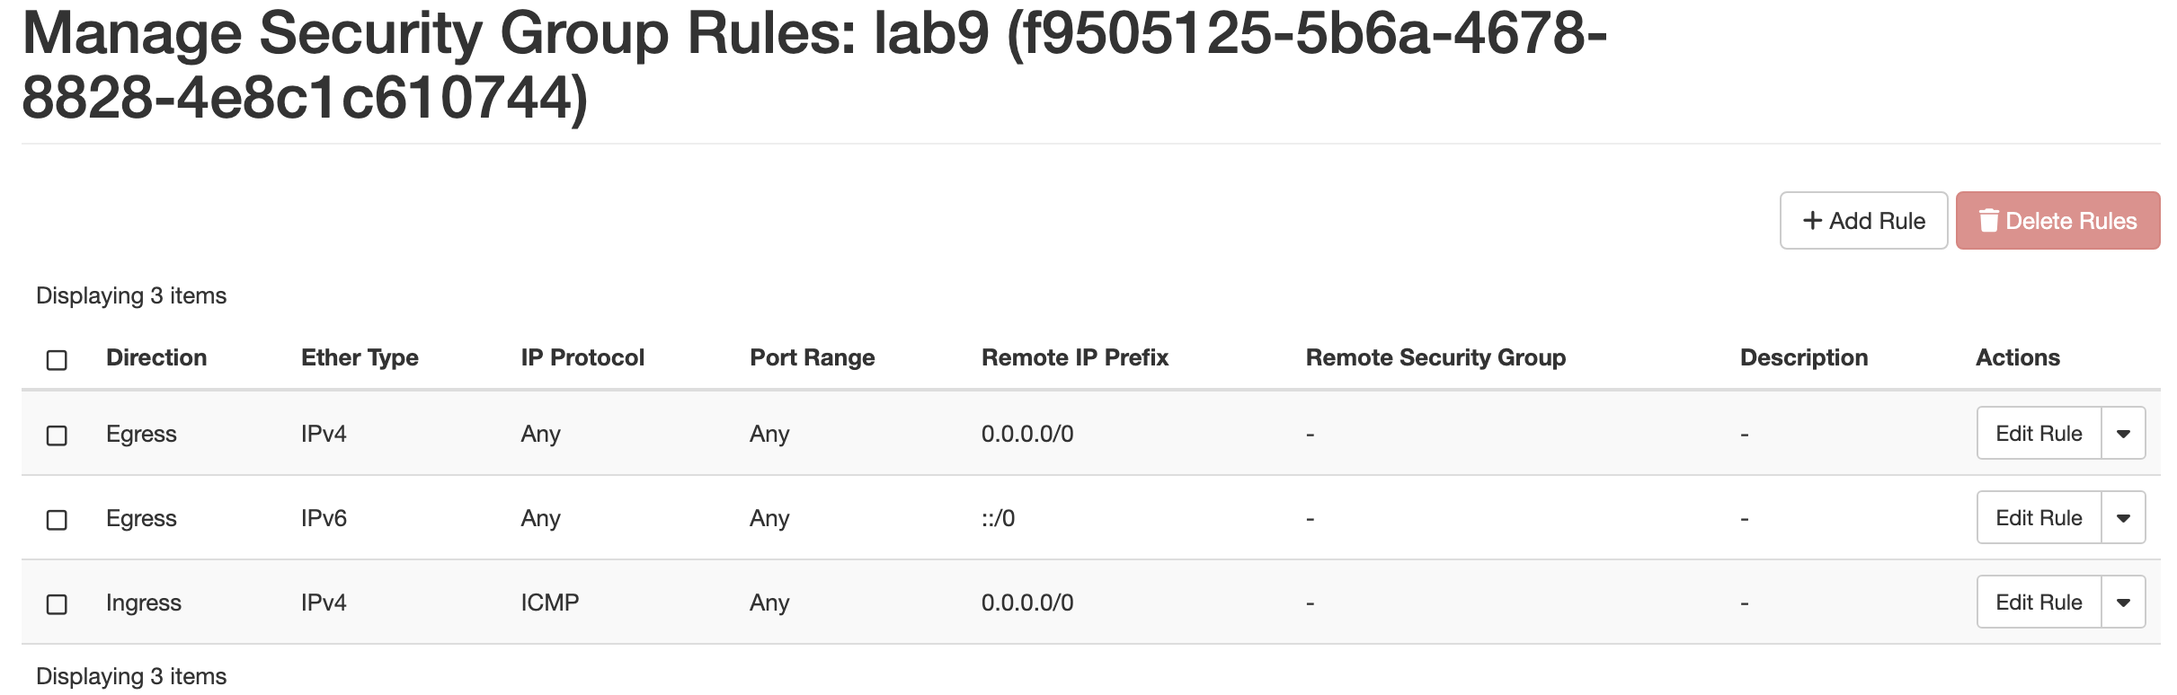

The script handles if rule is already there then skip it.

FRR instance is run and I have config file which is used to mounted in FRR to run it –

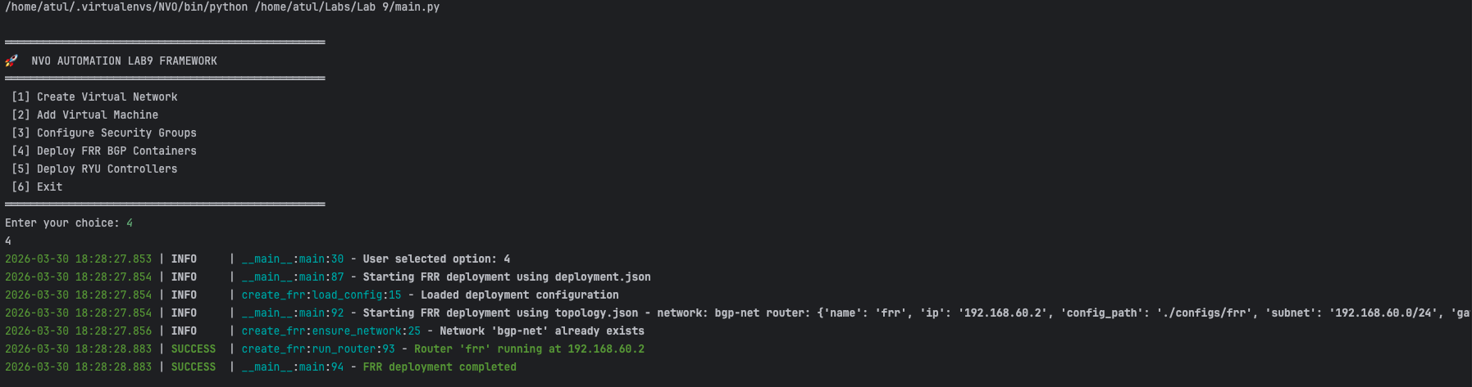

BGP summary –
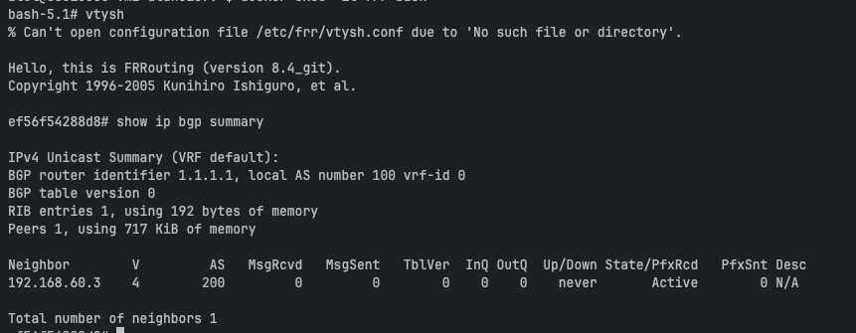

Option 5 is RYU controller deployment –
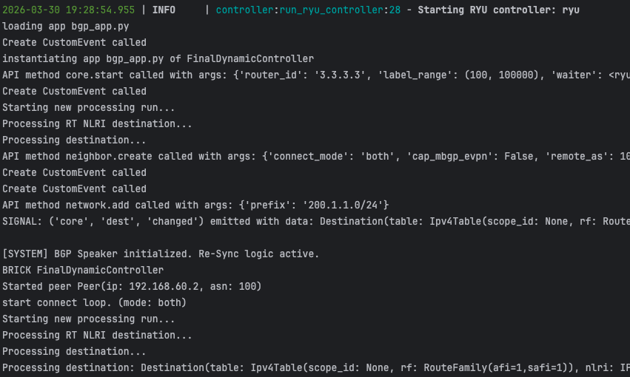

It uses same network as FRR instance on docker network to ensure it can directly talk to the FRR container to establish BGP.

From FRR we could see the connectivity as well –

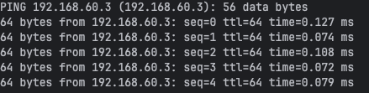

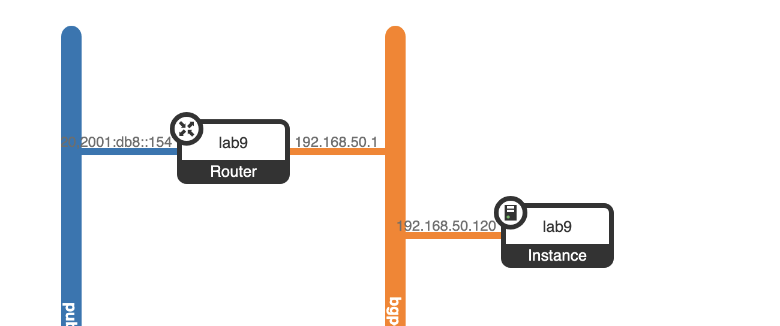

FRR and RYU on docker container –

